Furkan Taha Unal S22289

Basic of Java programming

Sławomir Aleksander Dańczak

Game Project

Hello, I will tell you about the Game I designed. This game I designed has a story, actually it is not just a project. the name of the game is "Çukur”. The word Çukur is a Turkish word and its meaning is pit. this is a neighborhood name. This neighborhood actually does dark things. And it's so strong that even the police can't enter the neighborhood they fear and people from this ruin are tattooed like this <⋯>

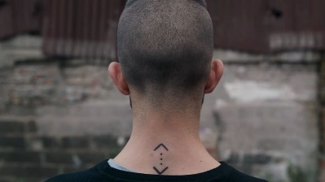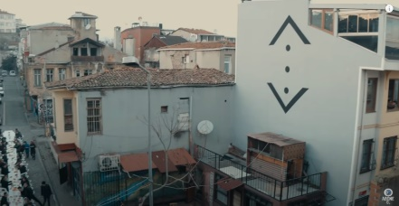

The TV series of this neighborhood has started to be shot and has been continuing to shoot for 5 years. What does it have to do with the game? has something to do with the game. If you get out of the scene in the drama you'll die or get injured so the Çukur or Pit won't come out of you.   
everyone who goes comes again.

I can move on to explain my game. When you run the game you have to enter a name.

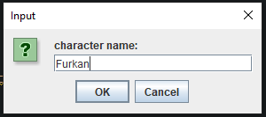

If you do not enter a name, the game will be closed and giving error like this!

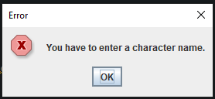

After entering your name, my game will open. Our game progresses from easy to difficult. how is it like this. there is a circle on the screen, so it's a pit. this hole is gradually shrinking and the character does not lose health when character is in this pit, but if character goes out of the pit, his health decreases. And this pit shrinks and disappears after a while. and the game goes from easy to hard. There are metkits in the game, when you use them, your health increases by ten percent. and there is money in the game. you can collect money on the map. And the blue square on the screen is our character so it is we. and in the upper left corner of the screen it says character name, character health , metkit is number and my character has collected money. it looks like this when playing a game.

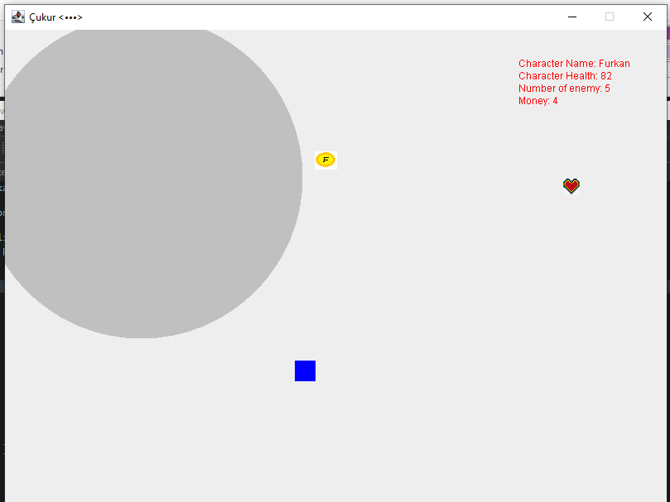

After the pit is over, the challenging task begins. To survive, you have to be faster and you need to collect and use metkits quickly.

My character moves left and right up and down with the following keys.

And you can use metkit with letter M.

my mettle looks like this.

my money looks like this.(There's the letter F in the coin because I designed it and it's my initial)

my character is a sweet little blue square.

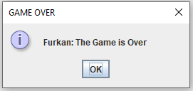If your health is 0, the game will be over and the screen will show Game Over.

I hope you enjoyed my game, professor. already Have fun playing the game.